Dear Mr Meecham,

I fear you may be about to do something awful. I fear that you may be about to support the pushing through a draft Local Plan based on the most recent OAHN figure of 550dpa. You wrote recently to Cllr Cawthron that “we have validated the original SHMA”. I am sure you know that is not true. The original SHMA was for 705dpa. Far from being validated, this has been comprehensively discredited.

What is required now is some action on the motion passed at the last Local Plan committee to which required officers to “share their calculations with the Members of the Committee”. To date you have not shared a single calculation with me.

In John Hollis’ report dated January 2016, he states (section 2.15) that the “UPC in any base period of a population projection would be mainly due to inaccuracies in migration estimation”. He makes no attempt to say that 2001 or 2011 census data was wrong in any significant way and concludes that “The net result is that while the population rose to a peak of 140,500 in 2008 it declined to 139,100 in 2011 before starting to rise again. Over the thirteen year period the range of the total population was less than 1,500 or barely 1% of the population”. The population was flat over this period.

Nonetheless he goes on to show the following graph in section 4.2.

Figure 10: Tendring DC: Population: 2001-37: Projections compared (thousands)

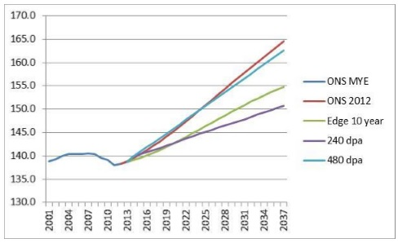

Just how does a flat trend 2001 – 2013 become a rising trend 2014 – 2037? None of the members on the committee can possibly know BECAUSE WE HAVE NOT SEEN THE CALCULATIONS ! These are Edge projections and even Mr Hollis only manages to describe these as “feasible” (section 3.6). Mr Hollis lists a range of unanswered questions (section 3.5) including “Are the high levels of UPC estimated by ONS realistic or have there been reasons apart from incorrect migration estimation for the rolled-forward estimates to have been too high compared to the 2011 Census based estimates?”. In short, do these figure make the same mistake today that was made back in 2001? Those projections forecast immigration that did not happen. What possible reason can there be for thinking it will happen now?

There are many other questions, including but not limited to:

* What effect would using a lower TFR have? (JH covering email 12/01/2016)
* Would using 2003-2013 as the base period, rather than 2003-2007 reduce the housing requirement by 145dpa? (Section 3.3)
* Would recognising the increase in residential care from 1,236 to 2,398 seems to give a one-off reduction of 553 dwellings? (Section 4.9)

The population forecast for 2016-2032 certainly looks to be horribly WRONG. If it is right then you should have no problem explaining the calculations that have been used. Your refusal to cooperate reinforces our reasonable suspicion that you have something to hide.

Now would be a very good time to share the calculations with us, ideally with the direct access to John Hollis that I requested on 9th Jan 2016.

Yours sincerely,                Ashley

____________________________

Cllr Ashley Mooney

t – +44 (0)7947 127595

e – [cllr.amooney@tendringdc.gov.uk](mailto:cllr.amooney@tendringdc.gov.uk)

Blog – [www.ashleymooney.uk](http://www.ashleymooney.uk/)